**OPERATORS**

**AND**

**EXPRESSIONS**

SARTHAK SANAY

**(1) AIM:-**

To write a program in C which checks whether a year given by the user is a leap year or not by using logical operators.

**CODE:-**

**#include <stdio.h>**

**int main()**

**{**

**int year;**

**printf("Enter year: ");**

**scanf("%d", &year);**

**if (((year % 4 == 0) && (year % 100!= 0)) || (year%400 == 0))**

**printf("%d is a leap year!", year);**

**else**

**printf("%d is not a leap year!", year);**

**return 0;**

**}**

**OUTPUT SCREEN:-**



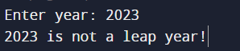

**(2) AIM:-**

To write a program in C to calculate the area of a triangle using Heron’s Formula.

**CODE:-**

**#include <math.h>**

**#include <stdio.h>**

**int main()**

**{**

**int s, a, b, c;**

**printf("Enter the value of semi-perimeter (s) : ");**

**scanf("%d", &s);**

**printf("Enter side a : ");**

**scanf("%d", &a);**

**printf("Enter side b : ");**

**scanf("%d", &b);**

**printf("Enter side c : ");**

**scanf("%d", &c);**

**double x = s*(s-a)*(s-b)*(s-c);**

**float area = sqrt(x);**

**printf("Area of the triangle is %f", area);**

**return 0;**

**}**

**OUTPUT SCREEN:-**

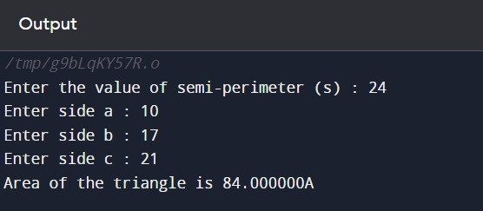

**(3) AIM:-**

To write programs in C to demonstrate the usage of arithmetic, relational, logical, and bitwise operators.

**CODE 1:- (Arithmetic Operators)**

**// Program in C to demonstrate the use of Arithmetic operators**

**#include <stdio.h>**

**int main()**

**{**

**int a=20, b=10;**

**printf("%d + %d = %d\n", a, b, a+b); // Addition**

**printf("%d - %d = %d\n", a, b, a-b); // Subtraction**

**printf("%d * %d = %d\n", a, b, a*b); // Multiplication**

**printf("%d / %d = %d\n", a, b, a/b); // Division**

**return 0;**

**}**

**OUTPUT SCREEN 1:-**

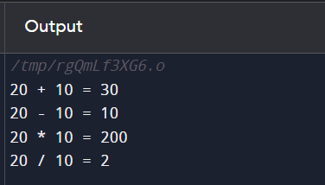

**CODE 2:- (Relational Operators)**

**// Program in C to demonstrate the use of Relational operators**

**#include <stdio.h>**

**int main()**

**{**

**int a = 10, b = 20;**

**// Using ternary operators to return the output**

**printf("%d==%d is %s\n", a, b, a==b? "true" : "false"); // equal to**

**printf("%d!=%d is %s\n", a, b, a!=b ? "true" : "false"); // not equal to**

**printf("%d>%d is %s\n", a, b, a>b ? "true" : "false"); // greater than**

**printf("%d<%d is %s\n", a, b, a<b ? "true" : "false"); // less than**

**printf("%d>=%d is %s\n", a, b, a>=b ? "true" : "false"); // greater than or equal to**

**printf("%d<=%d is %s\n", a, b, a<=b ? "true":"false"); // less than or equal to**

**return 0;**

**}**

**OUTPUT SCREEN 2:-**

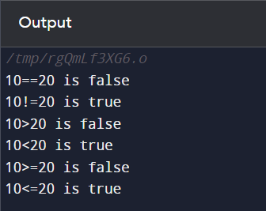

**CODE 3:- (Logical Operators)**

**// Program in C to demonstrate the use of Logical operators**

**#include <stdio.h>**

**int main()**

**{**

**int a=1, b=0;**

**// Using ternary operators to return the output**

**// Logical AND**

**printf("(%d && %d) is %s\n", a, b, a&&b ? "true":"false");**

**// Logical OR**

**printf("(%d || %d) is %s\n", a, b, a||b ? "true":"false");**

**// Logical NOT**

**printf("!(%d) is %s\n", a, !a ? "true" : "false");**

**printf("!(%d) is %s\n", b, !b ? "true" : "false");**

**return 0;**

**}**

**OUTPUT SCREEN 3:-**

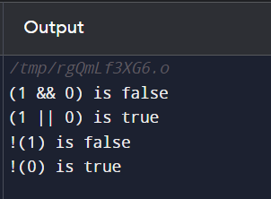

**CODE 4:- (Bitwise Operators)**

**// Program in C to demonstrate the use of Bitwise operators**

**#include <stdio.h>**

**int main()**

**{**

**int a= 5, b= 3;**

**printf("Bitwise AND: \t%d & %d = %d\n", a, b, a&b);**

**printf("Bitwise OR: \t%d | %d = %d\n", a, b, a|b);**

**printf("Bitwise XOR: \t%d ^ %d = %d\n", a, b, a^b);**

**printf("Bitwise NOT: \t~%d = %d\n", a, ~a);**

**printf("Bitwise NOT: \t~%d = %d\n", b, ~b);**

**printf("Left shift: \t%d << 1 = %d\n", a, a<<1);**

**printf("Right shift: \t%d >> 1 = %d\n", a, a>>1);**

**return 0;**

**}**

**OUTPUT SCREEN 4:-**

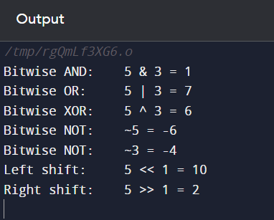

**(4) AIM:-**

To write a program in C that swaps two numbers using arithmetic and bitwise operators.

**CODE 1:- (Swapping using Arithmetic operators)**

**// Swapping two numbers using Arithmetic operators**

**#include <stdio.h>**

**int main()**

**{**

**int a = 5, b = 10;**

**printf("Before swapping: \ta=%d b=%d\n", a, b);**

**a= a+b;**

**b= a-b;**

**a= a-b;**

**printf("After swapping: \ta=%d b=%d\n", a, b);**

**return 0;**

**}**

**OUTPUT SCREEN 1:-**

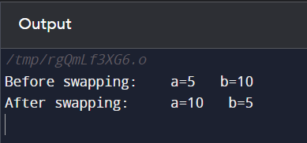

**CODE 2:- (Swapping using Bitwise operators)**

**// Swapping two numbers using Bitwise operators**

**#include <stdio.h>**

**int main()**

**{**

**int a = 5, b = 10;**

**printf("Before swapping: \ta=%d b=%d\n", a, b);**

**// Swapping using bitwise XOR**

**a= a^b;**

**b= a^b;**

**a= a^b;**

**printf("After swapping: \ta=%d b=%d\n", a, b);**

**return 0;**

**}**

**OUTPUT SCREEN 2:-**

